

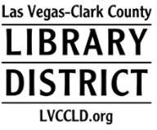**Public Comment Policy**

Las Vegas-Clark County Library District (LVCCLD)

Public Comment at meetings of the Board of Trustees of the Las Vegas-Clark County Library District shall be received and recorded consistent with Nevada Revised Statutes 241.021 and 241.035(2)